Simple PPC Secrets

“How To Get Non-Stop Traffic To Your Web Site! Pay-Per-Click Advertising Made Simple!”

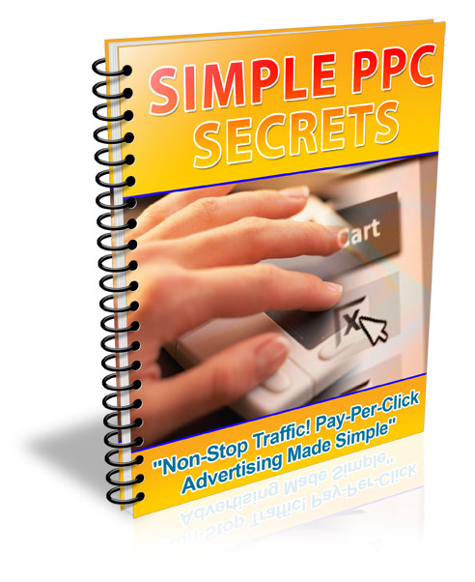

LEGAL NOTICE

The Publisher has strived to be as accurate and complete as possible in the creation of this report, notwithstanding the fact that he does not warrant or represent at any time that the contents within are accurate due to the rapidly changing nature of the Internet.

While all attempts have been made to verify information provided in this publication, the Publisher assumes no responsibility for errors, omissions, or contrary interpretation of the subject matter herein. Any perceived slights of specific persons, peoples, or organizations are unintentional.

In practical advice books, like anything else in life, there are no guarantees of income made. Readers are cautioned to reply on their own judgment about their individual circumstances to act accordingly.

This book is not intended for use as a source of legal, business, accounting or financial advice. All readers are advised to seek services of competent professionals in legal, business, accounting, and finance field.

You are encouraged to print this book for easy reading.

Table of Contents

How to Make Your Business “Click” 5

Maximum Web Promotion with PPC 8

How to Create a Profitable PPC Campaign Management 10

PPC Bid Management 11

The PPC Appraisal Program 14

Cash and Pay-Per-Click Affiliate Programs 16

In Closing: To SEO or To PPC? 17

Recommended Resources 20

Simple PPC Secrets

“How To Get Non-Stop Traffic To Your Web Site! Pay-Per-Click Advertising Made Simple!”

Click Here To Learn First Hand How To Make $1000's Per Day

How to Make Your Business “Click”



PPC stands for Pay-Per-Click - a popular advertising technique on the Internet. Found on websites, advertising networks, and especially on search engines, PPC advertising involves sponsored links that are typically in the form of text ads. These are usually placed close to search results, where an advertiser pays a particular amount to visitors who click on these links or banners and land on the advertiser's web page.

In essence, PPC advertising is all about bidding for the top or leading position on search engine results and listings. Advertisers do this by buying or bidding on keyword phrases that are relevant to their products or services - the higher the bid, the higher the spot on the search results, the more the people will find the ad (and click on it) to go to their websites (this is why some people call it "keyword auctioning"). Advertisers would then pay the bidding price every time a visitor clicks through the website.

PPC advertising is also known under the following names/variations:

- Pay per placement
- Pay per performance
- Pay per ranking
- Pay per position
- Cost per click (CPC)

PPC advertising is usually done with the following standard procedures:

- Setting up an account and/or deposit funds.

- Creating a keyword list.

- Choosing (and setting up) an account with a PPC search engine.

- Bidding on the ad placement, including the search result words or phrases.

- Writing out an ad copy.

- Setting up the 'landing pages' for your ads.

- Placing the advertisement in the search engine.

There are many benefits to Pay Per Click advertising, making it an effective way of promoting a business 'online'. Some of them are listed below:

- Get launched immediately. PPC advertisements are implemented very quickly - they can go 'online' within an hour after winning the bid and paying for it.

- Obtain specific, pre-qualified, and quality traffic. PPC provides you with a quality or a well-targeted traffic. Visitors are narrowed down into 'qualified' people who are actually looking for specific products and/or services that you offer - those who are more likely to become a 'lead' (a convert) and complete a transaction (either by buying your product or subscribing to the service that you are offering.

- Widen your reach. PPC advertising provides additional traffic to your site, aside from the natural or "organic" search engines.

- Track your investment. PPC advertising makes use of a tracking system that will determine exactly who comes to the website and what they do once they arrive - the length of their stay on the site and the number of pages (including the actual pages) that they view. These are valuable tools in determining statistics such as return on investment (ROI), acquisition cost-per-visitor, and conversion rates (the percentage of visitors who are converted into customers or leads).

Below are some important things to consider when planning on a pay per click campaign:

1. Know your product.

Take an inventory of the product and/or services that you have to offer (before anything else).

2. Stay within the budget.

Determine your daily or monthly budget; and stay with it. This means keeping your budget in mind, avoiding bidding wars if possible.

3. Bid just right.

Know how to bid right - a bid that is too high can exhaust all of your money, while a bid that is too low can make you lose that spot.

4. Watch the bottom line.

Measure your profit margin against your spending or expenses. Know when to stop and terminate your PPC program - if you spend more on advertising but have little or no sales at all.

5. Find the right keywords.

Decide which keyword phrases to opt and bid for. Do some keyword research, either by actually looking at existing search terms or with the use of online keyword suggestion tools, to know which terms are mostly used when searching for items that are related to your business. Focus on specific keywords, not on general ones.

6. Write effective ads.

A good PPC ad is that which can persuade and move a searcher. There are several approaches to this:

- Discount offers
- Testimonials
- Celebrity/famous endorsers
- Money-back guarantees
- Free trials or sample offers
- Freebies
- Reverse psychology
- Major benefits ("Lose weight")
- Direct instructions ("Click here")

7. Maintain a professional-looking site.

Your web content should be regularly updated and checked for spelling and grammatical errors. There should be no broken links or images. The website should be simple - designed in such a way that it will be easy for visitors to navigate and load. Include contact details to create a good impression among potential customers.

Maximum Web Promotion with PPC

Engaging in pay-per-click (PPC) advertising has its own benefits and drawbacks.

Business nowadays is doing different kinds of austerity measures when it comes to advertising their products and services. This is because of high rates of placing ads on print and on television. But there is a fast growing approach that businessmen can utilize to bring their services closer to the people and that is through Internet Marketing.

One tool that is causing Internet marketing popularity is PPC advertising. This is a technique used in search engine marketing that requires one to pay a fee every time someone clicks an ad on your website. Usually this placement is done through a bidding process. If you are a top bidder for your keywords/phrases, you are sure to be on the number one spot on all search engines. Just be sure of the effectiveness of your ad copy to get the most number of clicks you need for your business.

PPC – The Pros

- You need not be a genius in computer and technology to be able to run this ad campaign.

- Immediate results are seen after a few days.

- No need to make a website conform to the SEO rules.

- Nothing to lose even if you do not top the pages of different search engines. You can still always choose PPC advertising.

- You can make use any search engine available.

- You can type in any keyword you like.

PPC – The Cons

- Fixed payments every month to the search engine you choose.

- Pay for each click received by your website. At times, visitors are just competitors or people playing pranks on search engines. This hassle wastes money you put in to this advertising.

- Inability to pay for the fees next month would mean removal of your website on the paid listings.

- This advertising can only be used temporarily because it is difficult to handle in the long run.

- Pay-per-click pricing can be costly for long periods of time, therefore, this should be stopped after an ad campaign.

But how exactly PPC advertising can increase traffic, leads and sales?

PRE-QUALIFIED TRAFFIC. All visitors of your website are already considered as a qualified consumer or buyer of your product. PPC advertising leads your customers to you for a lesser cost.

INSTANT EXPOSURE, IMMEDIATE PROFITS. PPC search engines enable you to get your desired results fast. They will have your website live within just a few hours which means immediate increase in sale.

CONSISTENT TOP LISTINGS. This is to get your website on top of the sponsored search results for free. You just have to choose the keywords related to your site and business and place them within your web pages. After this, you are done.

PPC advertising enables advertisers to control their advertising campaigns. Advertisers have effectively targeted their audience and set their own price per click. PPC advertising networks provide the platform to identify the desired audience by geographic setting, topic and industry. These networks have a list of websites of the publishers where the ads will be placed.

Tools are provided by the networks to check how the pay per click limit is working for a certain advertiser. If its still competitive, would it be even listed among the paid search lists or does it generate sales? Of course, if the advertiser made the highest bid, the better chances the ad will be seen in the search engine. These networks too provide protection for the advertisers against click fraud. This advertising set-up allows advertisers to set a daily budget for his ads, thus, less spending for unnecessary clicks. Advertiser will never go over his budget.

In PPC advertising, what are important are the keywords and phrases. You have to select at least 10 "very specific" keywords that would give you the best traffic in the search. Then, write the ad creatively but straightforward. Tell the truth about your product or service and do not lie. Good thing if your product or service will not disappoint those that are relying on your ad's promise - but what if it did otherwise? Important too is the clarity of the ad. Do not use very vague languages. Include important details like the price.

Important! You should also remember to budget your bids. Do not go overbidding because you will only lose your money and do not go so low that your ads will never get the chance to show up. Check your profit against your spending. If you see no progress then most likely you have to drop your ad campaign.

More and more advertisers have been using PPC advertising and it will continue to grow faster than any online advertising techniques. From revenues of $2.6 billion in 2004 to $5.5 billion in 2009, cost per click will dramatically go up as well from $0.29 to $0.36.

PPC advertising is new in online marketing and it is going to continue in the years to come. For advertisers, this means increase revenues with fewer advertising expenses, savings, more sales, good return of investment (ROI) and effective ad campaigns in the days to come.

How to Create a Profitable PPC Campaign Management

Certain keywords or phrases that people type into a search engine lead to hundreds and hundreds of search results that pertain to that specific keyword. Businesses that want to advertise on the net using a PPC campaign have to come up with a plethora of keywords that is associated to the business that they are running; so when potential customers type in these keywords, it will lead them to their business site.

This is pretty much the whole concept that operates behind PPC. This is how a PPC campaign brings in traffic to your site, with the selection of the right keywords that people can search through the net.

Some keywords tend to be more expensive than others, especially popular ones. It is vital to select the right keywords, in order to get your money's worth. This is why it is important to manage you PPC campaign wisely. Sometimes you are better off opting for the less popular keywords that are not so expensive, especially if you have a limited budget. Some businesses even hire the help of a consultant to manage their PPC campaigns.

There are a lot of experts that specialize in PPC campaign management. They come with strategic plans, and assess the need of their clients. They then come up with a PPC campaign that caters to their client's specification.

This is why big online businesses seek the expertise of a professional to run their PPC ad campaign, because the right set of plans, can potentially bring in a large amount of profits. The more keywords you have, the more you increase the chances of customers clicking these keywords that would lead them to your website. There are also some software you can purchase, such as GoToast, or Bid Rank. These software programs track down your keywords listing.

If you are running a business online, and are planning to run a PPC campaign, it is advisable to purchase keywords that are extremely related to the theme of your business. This way, people know what they are getting, and don't get confused about the content of your website. The secret is to use keywords or phrases that are searched frequently, but cost very little.

The chances are, the longer people stay in your site, the likelihood of these potential customers making a transaction.

But first thing’s first: you must lure them into your turf.

This is why a lot of entrepreneurs spend a large amount of their budget on advertising, because they know that the right advertising campaign can start the ball rolling.

Also, you should do some research before you start your PPC campaign. There are a lot of PPC search engines to choose from. Those who are less renowned charge less for the same keywords that you'd find in the bigger PPC search engines.

The great thing about PPC campaigns is that you can reach a worldwide audience. Advertising online means global marketing.

Most PPC search engines require a monthly payment in exchange for their services. But if you fail to make payments, they will automatically take your listings out of their search engines. So make sure that you pay your monthly bills, so all the efforts that you put into your PPC campaign don't go to waste.

The potential earnings that can be generated by starting a pay per click campaign is significant. That's why a lot of online businesses now are trying to get in on the act. Now, with the right set of keywords, and a smart PPC campaign management plan, more than ever, online businesses are bringing in the big bucks.

PPC Bid Management

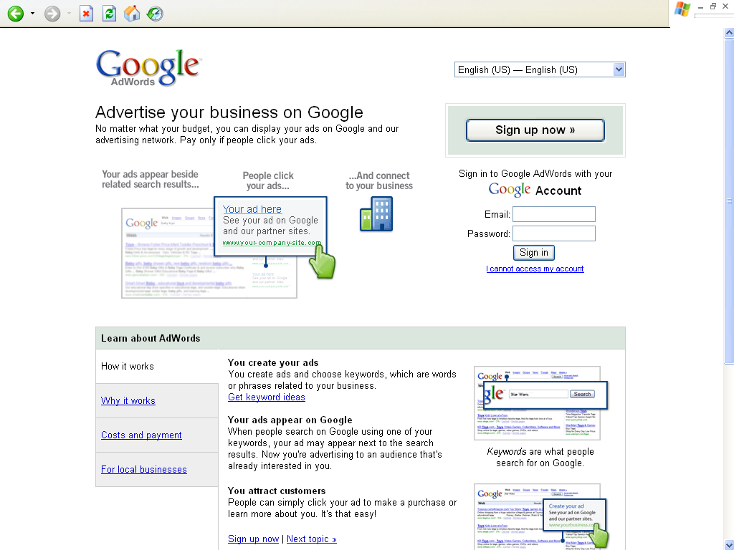

Search engines such as Overture, Google Adwords, Search Yahoo and Miva offer top positions among the sponsored listings for particular keywords/phrases you choose. The idea for bidding is you have to buy/bid on keywords/phrases relevant to your business. The highest bidder gets to be on the top of the search result listing and the second highest bidder, of course, gets the next top listing and so on. Every time a visitor clicks on your website, you will have to pay the same amount that you bid on that particular keyword.

PPC can be very costly, time consuming and sometimes not worthy. But if you know how to go about the step-by-step procedures, PPC is a welcome change to traditional advertising.

If you do your searches for products, articles and auctions in the net, you usually type in a keyword or a set of phrase to guide you in your search. Either you use Google or Yahoo Search depending on where you are most comfortable at and where you usually get the best results. As soon as you key in the search button, immediately a long list of keywords or phrase will be displayed containing the keywords you key in. The first or the top link that you saw is most likely the one who bids the highest for that keyword you type. In this way, businessmen will produce the desired results; they get to be advertised, at the same time, saving and spending only for the clicks they need that might translate to potential sales.

The way to start PPC bid management is to identify first the maximum cost per click (CPC) you are willing to pay for a given keyword or phrase. CPC varies from time and even search engine to search engine too. Maximum CPC can be measured by averaging the current costs of bids (bids range from $0.25 to $5). Average of these bids is to be used as the maximum CPC to begin with. As your ad campaign progresses, the actual conversion rate (visitors turning to potential buyers/sales) will be determined and you may have to adjust your CPC (bidding rate) accordingly.

When you start to bid, see to it that you adopt different bidding strategies for various search engines. Search engines have their own PPC systems that require different approaches. It is also worthy to identify different bids for the same keyword phrases in various search engines.

Another thing, it is wiser not to bid for the top spot for two reasons: 1) It is very expensive and impractical, and 2) Surfers usually try different search queries in various search engines before they settle on the right one that fits to what they are looking for. This hardly results to conversion. Try to bid for the fifth spot instead and work your way up.

If you are now going steady on your PPC biddings, it is time for you to develop your own bidding strategy accordingly. It is important for you to track down which sites bring the bulk of your traffic and identify the ranking of your paid ads. This will help your bidding strategy to be effective and you should also decide where you want your ad to be positioned. Usually your maximum CPC will limit your choices.

Bid gaps (e.g. $ 0.40, 0.39, bid gap, 0.20, 0.19, 0.18) occur when there is a significant price increase to move up one spot in the PPC rankings. It is best if you take advantage of the bid gaps by filling them in so you can save up your cents to other bidding opportunities. Often there are keywords worthy of lesser bids to get the appropriate ranking on the list and produce a good number of clicks and higher conversion rate rather than bidding higher but having a poor conversion rate. You have to put in mind that overbidding too is not good but rather the best position for the most effective bid.

Using pay-per-click bid management in promoting your website will only be successful if you take time building many lists across many engines and studying the performance of every listing. In this way, you can make the most value from what you spend in the bidding process. The key is to use the necessary precautions to stay ahead of the competition.

Bid Management Tools

In ensuring best results, you may use bid management tools. There are accepted and approved management tools that will help you in your bidding. They are categorized in two different types:

- Web based (services by monthly subscription) or,
- PC based (a purchased software)

Monitoring tools too may help in the tracking down of your keywords/phrases and search engines as to which among them often generate sales, overall and in relation to your cost per click. This is what you call return of investment (ROI) monitoring.

These bid management tools may include additional functions that may not get from online marketing tools that are readily available. Other tools can monitor competitor’s bids, produce reports for different parties and offer the ability to interface with multiple PPC engines. This is particularly helpful to those who manage more than a hundred keywords across several PPC engines to boost productivity and save time.

The PPC Appraisal Program

This program is very simple to download, entirely free and really works!

Requiring no sponsoring, no costs at all to join, once it has been set up, the only thing you do is leave your computer on and the system will just automatically run and you can trace your income by the second.

This program operates comparable to “click on a search engine and get paid” programs, with the exception of the following:

- It is run automatically similar to auto surf, so there is no need for you to click on any link.

- It does not provide you with only one search engine, but there are at least twenty one now running.

If you continually run your computer for twenty four hours a day, you may earn up to fifteen dollars a day. At the end of the month, when they will be adding up to two hundred more search engines, you may earn up to sixty dollars a day, not doing anything, just be online.

In addition, you get another five percent of your referrals running time; these referrals could go as far as four levels.

Every search engine builds up an independent total of your time surfing. You must reach sixty dollars before payment be done by each of the search engine.

Normally, when you are running your computer online for twenty four hours each day, without any referral, for you to reach sixty dollars, it would more or less take you up to two months, with the now running twenty four search engines. Now consider this, sixty multiplied by twenty four will equal to one thousand four hundred forty. This is how much you will make in two months, of doing nothing.

Signing up:

Take note of this URL, as you will use this as your sponsor:

http://www.ppcappraisal.com/register.php?fT=1&RefId=14387

- Go to http://www.ppcappraisal.com/register.php?fT=1&RefId=14387 and fill out the form.

- Where it is asking for the company name, put PPC appraisal. For the URL, put ppcappraisal.com. For tax ID, put N/A. Fill the rest of the form with your personal information Take note that PPC appraisal does not accept any email address with full stops or non alphabetic characters in it. If you are in need of a new email address just for this intention, you can register at http://www.hotmail.com/ ; they offer a free account.

- Log in (this will take you on to a menu).

- Hit “select all” at the pages’ bottom.

- Go back again to the bottom of the page and hit “select all” then “request”

- There will be more than two pages that will appear. Do the same for all of the pages.

- Go to your PPC account and click on “statistics” and observe the entire search engines appear and your total earnings.

- Download “test 33” (go to http://66.84.56.206/ppc/test33.exe) and make sure you save it to the desktop.

- Log in to PPC appraisal, select campaigns on the menu.

- Write down a copy of your portal URL

- In the test33 browser, go to tools, analyst, act, setup; you will see two squares that are empty; on the lower left side, click append and wait for the pop up window to appear open.

- Inside that window, type in set 1 and hit OK.

- After which, it will fade away.

- Go back to tools, analyst, act, hit set 1 and the url will load.

- Go to tools, analyst and hit loop and then click on navigation.

- At the bottom, click on the word “six” and this will open up six different search engines.

- Now the test 33 will start on clicking all search engines.

- Do not adjust any settings. You can minimize the window and still work on your normal computer wok. It will just continue on clicking the search engines and will never interfere with what you do. These are search engines that use up or get a run through this particular program. They are doing this and making payments to improve or increase their numbers so they can have a better chance to compete with google or yahoo.

Cash and Pay-Per-Click Affiliate Programs

There are actually two types of PCC affiliate programs – those who pay a commission based on the number of clicks and the other based on the sales. The pay-per-click scheme is much more popular than pay-per-lead because the affiliate gets paid by just clicking the ad, regardless of whether the visitor buys from the affiliate merchant or not. Plus the chances of a visitor purchasing something from the affiliate merchant are not really that high.

Important! In choosing an affiliate program, read the fine print carefully – some pay-per-click programs get the ratio of the number of people who went to your site and the actual people who clicked on the ad. If you have a heavily targeted website, this can hurt your earnings.

How do I start?

Of course, you need to have a website. Depending on your target audience, choose the best affiliate merchant that is most related to your topic. For example, your website is about Carpentry then you can search for affiliate programs that sell tools used in carpentry.

However, if you don’t have a website, that’s not a problem. You can put up a content site about absolutely anything under the sun like ‘Taking Care of Dogs’ or ‘Decorating your own Home.’ But wait, its not over yet. We are faced by a dilemma – on how to increase traffic! You first need to get Internet surfers to see your website, then the ad.

How do I increase my traffic?

First, design your website in such a way that it will attract Internet users. A user-friendly site is always recommended so that the customers will know which one to click. Take into consideration the look and feel of the advertisement. If it doesn’t look professional, most likely, users will just ignore it. Place the ad on a strategic location – one where users can see it clearly. Visibility of the ad is always important.

Another way is to post a link to your website in forums, web communities, ezine articles or bulletin boards. However, this method requires a lot of effort – that defeats your purpose of getting easy money in the first place! The key is to do something once and forget about it. It’s like putting your business on autopilot. To maintain you pay-per-click business, be sure to track down site activity, so you are updated on how much money you are making.

Can I make more money?

If you think you can go to the next level, you can try a two-tier affiliate program. This gives you the power to recruit affiliates. Other than the money you get from your website’s clicks, you will also get a percentage of what your affiliate generates. Some companies give 30% to a soaring 50% commission on all referral sales.

Remember, you should be able to manage and monitor your affiliate program. If you can recruit more affiliates, then you can get paid more without even moving a finger! Choose affiliates that can most likely attract more Internet users and bring more traffic. You just have to know the right people.

In Closing: To SEO or To PPC?

The online community is definitely a large market place that you cannot ignore, especially if you have an Internet business. There are thousands if not millions of consumers that you can tap in the Internet.

At the same time, the Internet also poses a quite different challenge. The easy access that Internet provides also gives you as much competition as you can imagine. It is too crowded and congested.

Having a website is not enough to make your business running and able to compete. You must take other alternatives to give way for the online community to access your website at any rate or chance possible.

You have to expose your website. Make it known. It has to be visible. It has to be frequently targeted by consumers and surfers.

Invest in marketing your Internet site. There are basically two options available to you, the SEO and PPC. These two are probably the most desirable alternatives you can get for your Internet business as strategy for search engine marketing.

1. SEO

SEO stands for Search Engine Optimization. Some researches indicate that 60% - 70% of Internet surfers and users actually resort to using the Google search engine to find and locate web sites and pages, for any topic they desire. SEO is the process taken to make sure that the Internet uses will find your website when ranked among the top results of a search. This way you can make sure that you will be visible and can clearly stand out from the rest.

To get a search engine optimization, you will have to build on your own Internet site frequently hit Internet links to web site pages. The process will involve IBLN or Independent Back-Linking Network, wherein hundreds or even thousands of pages will be utilized to promote a particular website of a client.

In SEO, there is no need for you to pay for the clicks although it will require you to spend time doing research to get a favorable combination of ads and target audience. The SEO process is a long term one. It requires months, 6 months at the least, before the proper outcome is fully achieved, but once the goal is accomplished, you will definitely get a steady source of profit.

2. PPC

PPC gives way in advertising on a search engine. These are sponsored listings that you see whenever you make a search. There will be a charge whenever a visitor or web surfer clicks on any of your ads. There will first be a bidding process. The highest bidder for the price per click will definitely get the chance to be first listed in the search engine.

With this kind of advertising, you can still basically control your campaign as you get to create your own ad. You will also manage the target audience and still stay within the bounds of your budget. Most of the providers of PPC advertising will allow you to specify the target market, either by topic, industry or geographical location. You can also very well check if your ad gets to be shown at all and if it is competitive with the rest.

There are some guaranteed benefits when you get to maximize the PPC strategy.

- PPC lets you advertise to the whole of the online community. It is also relatively easy to set up.

- At first glance, PPC advertising may seem very expensive. Could it possibly happen that someone out there will go on clicking on your ad? This will definitely give you a large bill without the expected profit on your part. If this provides a lot of worries, be rest assured that there is a protection for you. Networks are able to recognize fraudulent clicks.

- You can also set a budget for a certain period. The moment your budget has been used up by the target number of clicks, your ads will no longer be displayed until the next period you want it again displayed.

- You will also be able to adjust well to changes in market demands and trends.

In deciding which of the two strategies will work right for you, think of your goals and of your resources. They definitely offer benefits and advantages that will work for your good. The better way to approach this two is to evaluate according to your short term and long term plans. Take the PPC course for your short-term goals and choose SEO if you have long term ones.

There world is out there for you now. Just make sure you do what will work best for your entrepreneurial endeavors and visions. The secret to success lies in your hands. Just study your options well and you’ll get exactly what you want

